# Alluvial Aquifer Problem Set 4 (estimated time 3 hours)

## Overall Project Goal (this was a real study).

The goal of the site model is to find a location for a well that can withdraw up to 1000 m3/day from the alluvial aquifer without causing the well to go dry. The alluvial aquifer was deposited in a valley incised into bedrock and hydraulically connected to the Rio de Manati. The alluvium will be used to filter the river water and serve as a pre-treatment. To do that, the travel time from the river to the well must be at least 60 days as required to eliminate surface water borne pathogens. We will use MODPATH to estimate the travel time to the well. Another consideration with final well placement is locating the well in an area that very rarely is inundated.

There are two phases to problem 4 that should reinforce what you have already learned, but give you practical experience with incorporating real data and some of the challenges you will face for a real-world problem. Note Appendix 1 has a description of the study area and data collected. The USB drive has data and images for this exercise in the folder “Problem4”.

Overview of Problem 4 Phase 1- Building and calibrating our initial model (2.5 hours)

Take the information collected in 1998 to characterize the system and build and calibrate your model using the depth to bedrock data, the slug test data, the steady-state water level map collected right before a step drawdown test and the step-drawdown test data and analysis by the Driller.

Overview of Problem 4 Phase 2 – Find a well location that will have a 60 day time of travel between the well and the river using MODPATH and will not go dry at a pumping rate of 1000m3/d (0.5hours)

## Starting ModelMuse and Importing a Background Image.

1. Start ModelMuse,
2. Set the number of layers to 1 and change the name of the aquifer.
3. Click the “No grid” button.
4. Select “File|Import|Image…”
5. Click the “Select Image” button and select contour.jpg.

There is a .jpw file associated with contour.jpg that has georeferenced information on the WGS84 latitude and longitude and increment for each pixel in the .jpg. ModelMuse uses this to figure out the coordinates of the upper left and lower right coordinates of the image. However, the coordinates are in decimal degrees, WGS84 datum. Decimal degrees is not a suitable unit for modeling. We will convert the coordinates to Universal Transvers Mercator coordinates UTM Zone 20N. Note this is a very small area and the UTM projection at this scale will not cause issues.

1. Select the block of cells in the table that contain the X and Y coordinates (Lon, Lat). You can select multiple cells by clicking on one of the cells and then hold down the shift key while clicking on another cell. The press Ctrl-C on the keyboard to copy the cells to the keyboard.

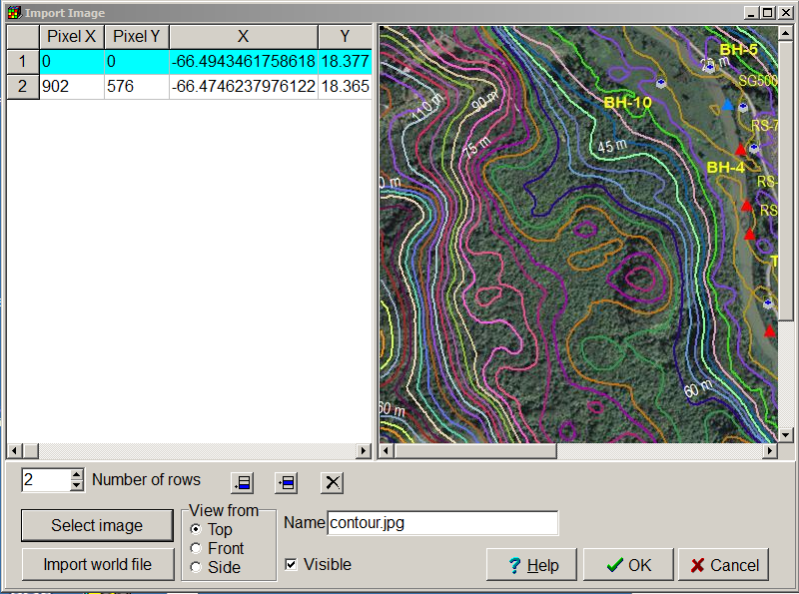

1. Go to <http://www.zonums.com/online/coords/cotrans.php?module=13>. This web page can be used to convert coordinates from decimal degrees to UTM coordinates. (Note this web site did not work correctly in Internet Explorer, but did work correctly in Google Chrome). By default, it expects the coordinates to be latitude (Y) and longitude (X) in that order. The coordinates copied from ModelMuse have longitude followed by latitude. In the web page, change the “Columns” to specify the data in longitude followed by latitude. The data are separated by tab characters and the model area is in UTM Zone 20 north. Enter that data on the web page. Once all the data have been set correctly, Click the Transform button. The transformed coordinates will appear in a separate window.  
   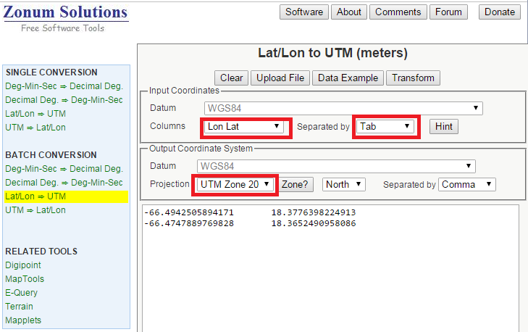
2. Copy the transformed coordinates to the clipboard and paste into a spreadsheet. If you are using Excel, you can use “Data|Text to Columns” to split the data at the comma.
3. Copy the coordinates from the spreadsheet and paste into ModelMuse. Click OK.
4. You can now zoom in on the image.

## Importing XYZ data of the ground surface.

The file riverarea.xyz contains coordinates of points where the elevation of the ground is known. The coordinates are in decimal degrees (WGS84). We will import these data points into ModelMuse to help specify the top of the model after we have converted geographic coordinates to Cartesian coordinates.

1. Open riverarea.xyz in a text editor. Copy all the data to the clipboard and paste it into a spreadsheet.
2. Split the data so that the coordinates and elevations are in separate columns. The last column is the ground elevation (longitude, latitude, elevation, WGS84 datum).
3. Use <http://www.zonums.com/online/coords/cotrans.php?module=13> to transform the coordinates into the correct UTM coordinates.
4. Copy the converted coordinates to the spreadsheet and align them with the elevations.

In ModelMuse, we will interpolate among these data points to specify the elevation of Model_Top. To do that we first have to specify which interpolation algorithm to use.

1. Select “Data|Edit Data Sets…” and then select the “Model_Top” data set. Set the interpolation method to “Natural Neighbor.” Click the Apply button.  
   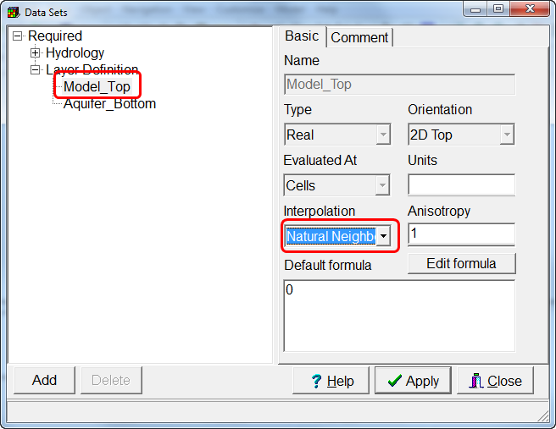
2. Next import the data points. Select “File|Import|Points…” Check the checkboxes for “Model_Top” and “Set values by interpolation.” Copy the data from the spreadsheet and paste into the table on the Data tab. Click OK. The object that is imported may obscure the background image. If so, you can hide the object.  
   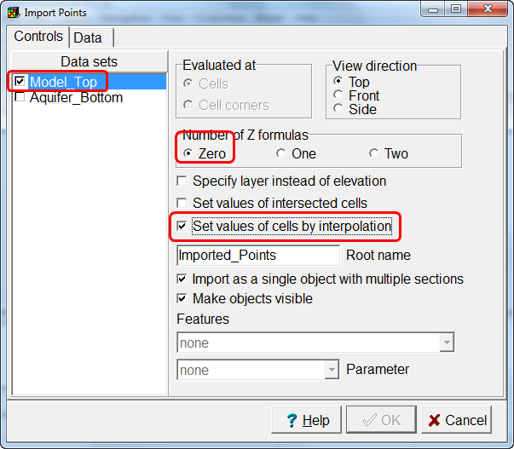 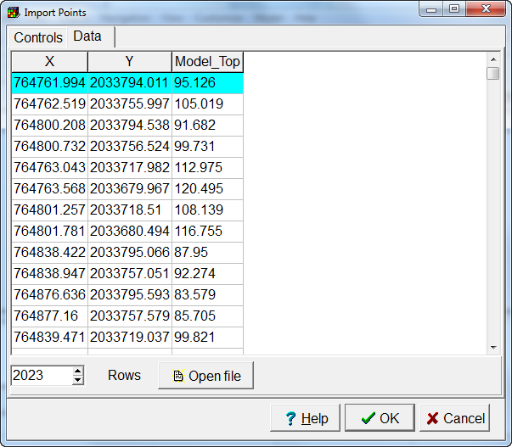

To test that the data was imported correctly, we will create a grid covering the entire image and use ModelMuse to create contours of the Model_Top data set. We will compare those elevations to the ones included in the background image.

1. Create a polygon object that roughly matches the area of the background image. Use it to specify a grid size of 10. Click OK  
   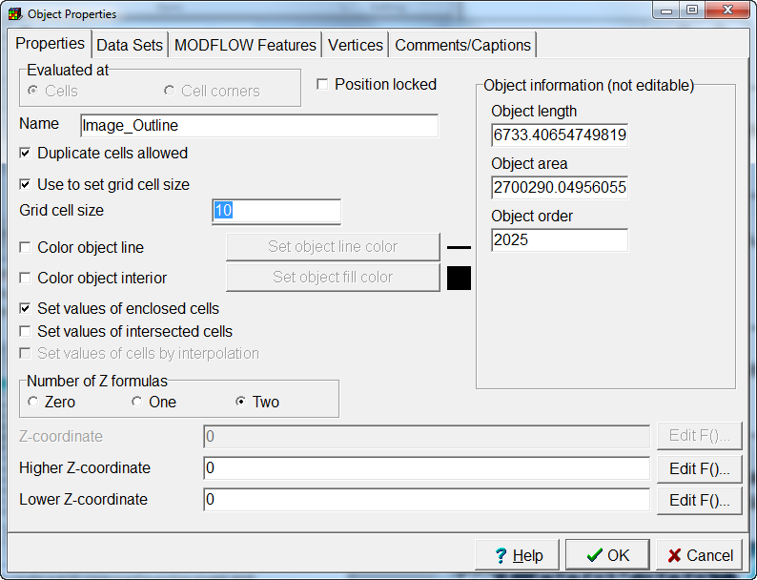
2. Select “Grid|Generate Grid”.
3. Select “View|show or Hide 2D Grid|Show Exterior.”
4. Select “Data|Data Visualization” and select “Contour Data”. Then select the Model_Top data set and click Apply. Compare the contours generated by ModelMuse with those embedded in the background image. The contours should be fairly similar but will not be identical.

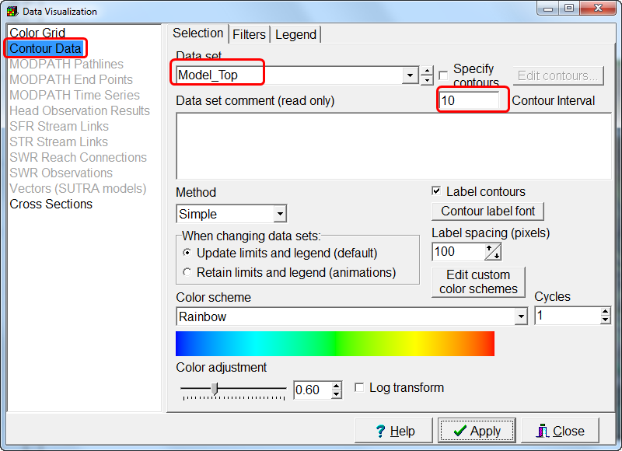

## Importing Image containing Domain outline.

We will import another background image: siteswalluvium.png. This image covers a larger area and has a higher resolution. It contains an outline of the extent of the alluvium. We will use extent of the alluvium as the outline of modeled area. The image contains the locations of a number of boreholes and other features. The coordinates of these features are in RiodeManatiwells.xlsx. You will need to convert those coordinates to UTM coordinates.

1. Open RiodeManatiwells.xlsx and convert all the coordinates to UTM coordinates.
2. Select “File|Import|Image” and select the siteswalluvium.png. In the image click on the locations of several of the boreholes or wells. Enter the coordinates from the RiodeManatiwells.xlsx spreadsheet. Some good boreholes to pick include. BH-5, BH-10, BH-6, and BH-1.

## Create a new grid of just the area covered by alluvium.

1. Either delete the object that was previously used to specify the domain outline or edit it in the Object Properties dialog box and uncheck the check box for specifying the grid size.
2. Create a new polygon object by tracing the orange line that represents the edge of the alluvium in siteswalluvium.png. In the Object Properties dialog box, Check the “use to set grid cell size” check box and set the grid cell size to 10. Click OK to close the dialog box.
3. Select “Grid|Generate Grid” to create a new grid.

## Set the active area of the grid.

At present all the cells in the grid are active. We will use the domain outline component to specify that only the cells inside the domain outline are active.

1. Select “Data|Edit Data Sets…” and change the formula for the Active data set to “False.”
2. Double click the domain outline object and use it to set the formula for the Active data set to “True.”
3. To check that the active cells have been specified correctly, select “View|Show or Hide 2D Objects|Show Active.

## Other options

1. Make the aquifer an unconfined aquifer.
2. Set the units of the model to meters and days in the Model|MODFLOW Options dialog box.
3. Set the initial head to the elevation of the top of the aquifer.
4. Have the model create a binary head file as output rather than an ASCII text file.

## Specifying the elevation of the aquifer bottom.

The boreholes and wells contain data on the borehole refusal depth. We will treat this as the depth to the bottom of the alluvial aquifer. The wells also have additional data on land surface elevation. We will import these data and use them to compute the elevation of the bottom of the alluvial aquifer.

1. First we will define a data set for the borehole depth. Select “Data|Edit Data Sets” and click the “Add” button. Change the name of the new data set to “Borehole_Depth.”
2. Now we will import the borehole depths and the surface elevation for the wells. Select “File|Import|Points…” and check the check boxes for the “Model_Top” and “Borehole_Depth.” Also check the “Set values of intersected cells” and “Set values of cells by interpolation” check boxes. On the Data tab, copy and paste the coordinates of the well, the land surface in meters (as Model_Top) and the borehole depth in meters. Click OK. You will get a warning that interpolation is not used on one of the data sets. In this case, the Borehole_Depth data set does not use interpolation. In this case, it won’t be a problem so choose “Yes” in the dialog box. The data points will be interpolated for the Model_Top data set. After the data has been imported, change the name of the new object to “Wells.”  
   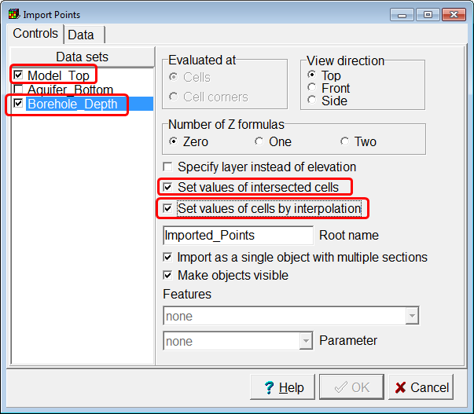
3. Repeat this for the boreholes but only import the borehole depth. You don’t need to check the “Set values of cells by interpolation” checkbox. After importing the data, change the name of the new object to Boreholes.
4. We will calculate the elevation of the aquifer bottom as Model_Top – Borehole_Depth. However, we don’t want to do that with a default formula. Instead, we will calculate the value at each well and borehole and interpolate between them. First specify the interpolation method of the Aquifer Bottom data set as Natural Neighbor.
5. Next we will change the values of both the Wells and Boreholes objects so that they set the value of the aquifer bottom. Select both the Wells and Boreholes objects. To select more than one object, click on the first one in the top view of the model to select it. Then hold down the shift key on the keyboard and select the other object. Then right click on the top view and a menu pops up that you then double click on the “Edit Selected Object(s) Properties” from this pop up dialog box.
6. In the Object Properties dialog box, the names of the objects will be displayed. Make sure that the right objects are being edited. Also note that the “Set values of cells by interpolation” is grayed. That is because it is specified differently for the two objects. For the Wells object it would be checked and for the Boreholes object it would be unchecked. Check the “Set values of cells by interpolation” check box.  
   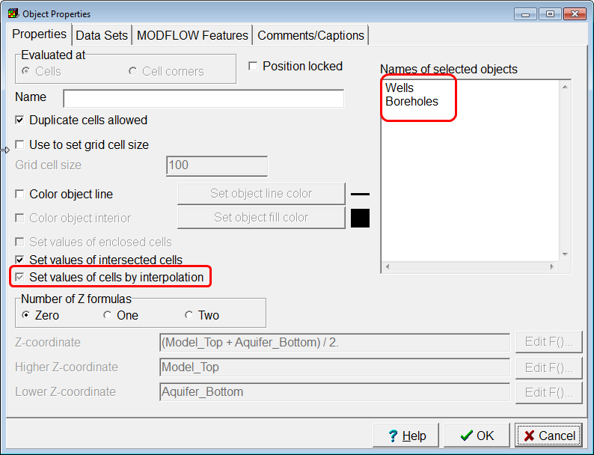
7. On the Data tab, check the check box for the Aquifer bottom data set. Then set its formula to “Model_Top – Borehole_Depth.” Note that the “Model_Top” checkbox is grayed. Be sure to leave it grayed. Click OK to close the Object Properties dialog box. At this point the Model_Top and aquifer bottom should both be defined.  
   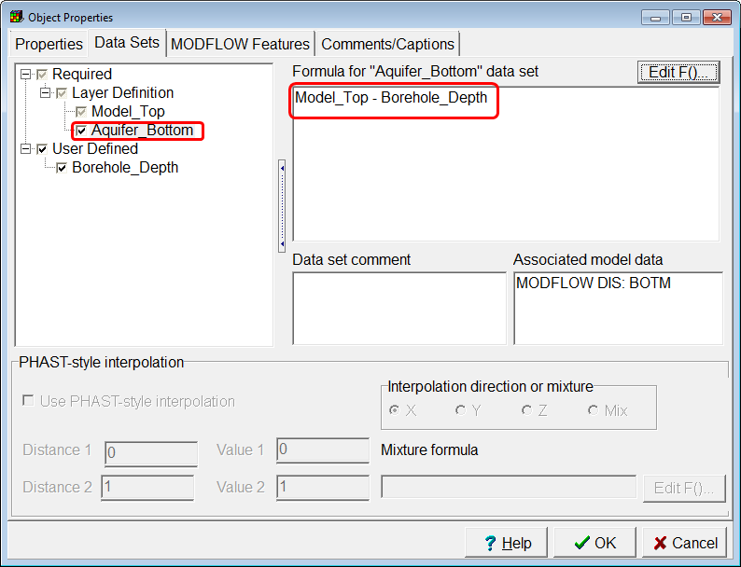
8. Try coloring the grid with the Model_Top and then with the aquifer bottom data set to make sure the values seem reasonable in the active area of the model.

It would be worthwhile to go over what is going on with the calculation of the aquifer bottom. The calculation takes place in several steps.

First the Model_Top” data set is calculated. This is done by first interpolating between the XYZ data we imported and the elevations of the well tops. However, after the interpolated values are assigned, there is another step. The Wells object sets values of intersected cells so in the cells the interpolated value is overridden by the value specified in the object. This is likely to be similar to but not identical to the interpolated value.

Next the value of the Borehole_Depth data set is calculated. No interpolation method has been assigned to it so the default formula is used to assign a value of 0 to all the cells. Then the values in the Wells and Borehole objects will assign values to the cells intersected by those object.

Then for each point in the Wells and Boreholes objects the values of the Model_Top – Borehole_Depth is calculated. Note that the Boreholes object does not set the value of Model_Top so the value it uses will be an interpolated value. Because the aquifer bottom data set has an interpolator assigned and because both the Wells and Boreholes objects set values of cells by interpolation the values for each well and borehole point will be interpolated to set values for all the cells. Then because the Wells and Boreholes objects also set values of intersected cells, the values of cells intersected by the objects will be set by them too. The values assigned to intersected cells might be slightly different from the interpolated values.

## Assigning Hydraulic Conductivity

We will assign the hydraulic conductivity in much the same way we imported the elevations. The one difference is that we can’t use interpolation to assign values to 3D data sets. However, we can use a formula in a 3D data set to link to a 2D data set and that’s what we’ll do.

1. Define a data set named Kx_2D and set its interpolation method to Natural Neighbor.
2. Slug tests were used to estimate the hydraulic conductivity in the wells. Import that information and use it to specify the Kx_2D data set by interpolation (Table 1 in appendix and spreadsheet).
3. Select “Data|Edit Data Sets…”and set the formula for the Kx data set to Kx_2D.

## Define River Boundary

The river is an important boundary condition for this model. We will assume the river bed sediments have the same hydraulic conductivity as the aquifer. We will assume the head in the river varies gradually from a higher value in the south to a lower value in the north. We will use the elevation of the top of the model to pick a few elevation points and interpolate the elevations along the length of the river.

1. Activate the River package in the MODFLOW Packages and Programs dialog box.
2. Select “Data|Show Grid or Mesh Values” and use the “All Data Sets” tab to display values of the Model_Top data set. Alternatively, you could just create contour lines of the Model_Top data set.  
   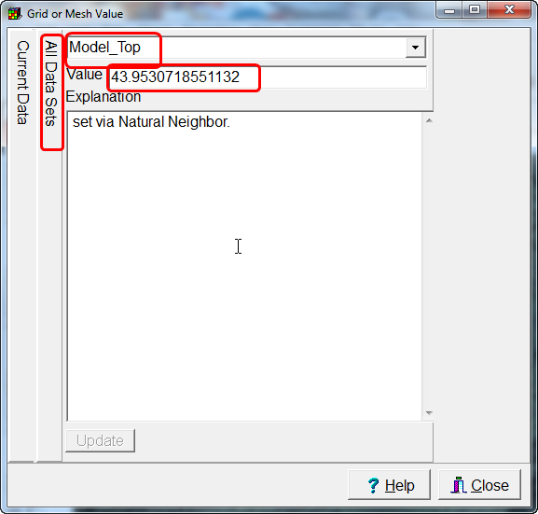
3. Draw a polyline object along the river. You may need to display the background image to see where the river is. For now, don’t use this object set to the values of any data sets of Model Features. Be sure to put a vertex near where each River Stage site in the image is located and the two temporary gages.
4. Select “Object|Edit|Vertex Values.” Then double-click on one of the vertices of the object. The Vertex Values dialog box will appear. Enter “RiverHead” as the key. For the value, enter the river stage value for the river stage site of the temporary gage in the table in the appendix or from the excel spread sheet (14 May 1998 Water level data). Repeat this for several more points along the length of the river. You may need to zoom in to read the site identifier and you may need to move your vertices to be closer the stage site.  
   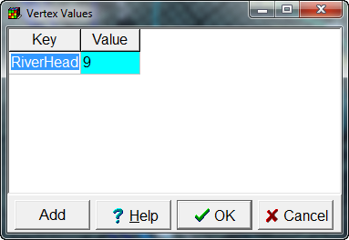
5. Use “Navigation|Measure” to measure the width of the river.
6. Select “Object|Select Objects” and double-click on the river object. In the Object Properties dialog box, activate the River package. Enter the starting and ending times for the model and then under “River Stage”, click on the “F()” button to open the Formula Editor. Locate the InterpolatedVertexValue function objects, select it, and then click “Function help” to read about what the InterpolatedVertexValue function does. You have already entered vertex values associated with “RiverHead.” So now use the InterpolatedVertexValue function to assign values of the River Stage. From the information provided, the river is well incised into the alluvium, so the bottom of the river bed can be set using the information on cross-section in the appendix as 10 meter below the MODEL_TOP or 10 meter above the bottom. You could also set it to be 1 meter below the river stage. If we set the conductance interpretation to “Calculated” and assume the river bed thickness is 1, the conductance per unit length of the river bed sediments would be the hydraulic conductivity times the river width. 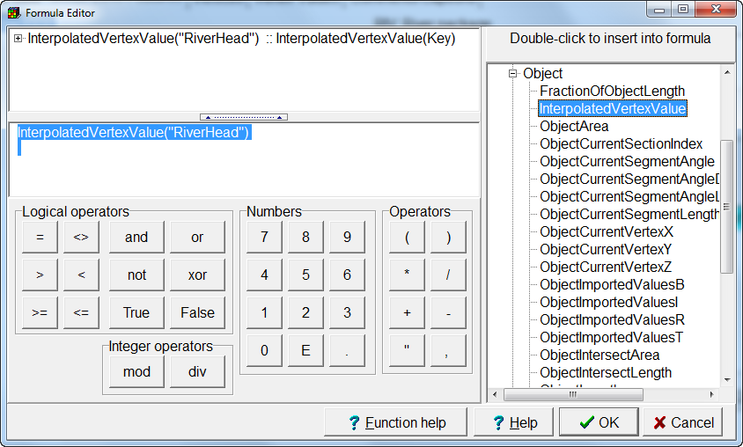  
     
   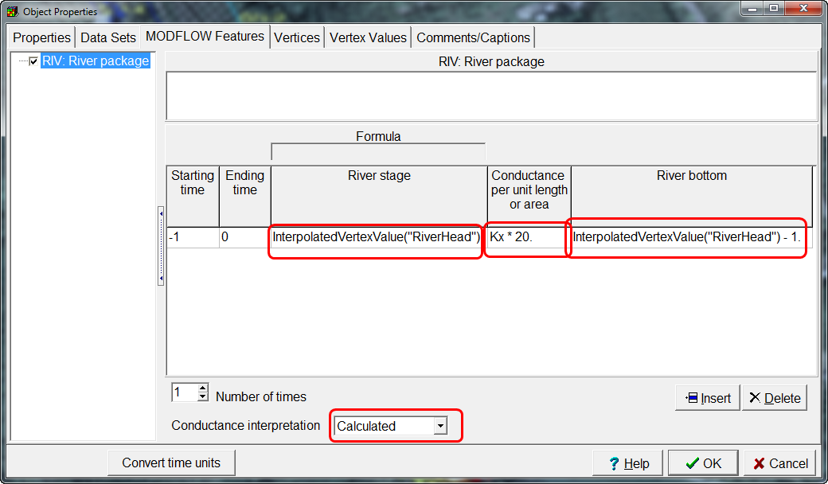
7. At this point you have enough information specified to do a steady-state model run. Do this and see if water levels look reasonable. Depending on how you set the river bottom and river stage and how high some areas of the model are, you may have to make corrections, so look at your error and warning file to see if you need to make any corrections to your datasets. Use Listing Analyst to look through your .lst file. Did the model converge? Check the VOLUMETRIC BUDGET is the mass balance preserved? If all is OK save the run with SS as an indicator for the entire name AlluvialSS for example.
8. Now we are going to use ModelMuse to create the Head Observation package. Start by saving this as AlluvialSSHOB. Entering the Observed Water Levels (heads) in Model Muse makes it easy to plot residual (observed minus simulated water levels). Below are water levels and river stage. To speed things up, in the Problem4 folder on th USB stick is a spreadsheet with the steady-state water levels at the wells in the columns needed to import points in ModelMuse for the creation of head observations for this steady-state simulation.
9. First turn on Head observations in the Model|MODFLOW Packages and Programs, by expanding the Observation menu and checking HOB: Head Obs.
10. Then go to Import Points in the File Menu and check Specify layer instead of elevation and Set values of intersected cells and select HOB: Head Observation package from Features Menu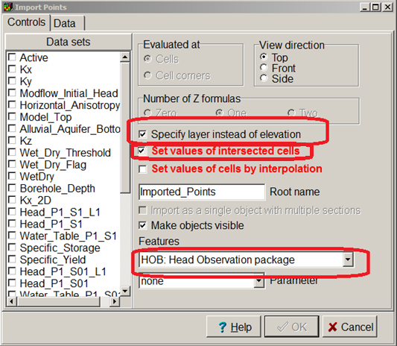
11. Now when you click on the data tab you will see the spreadsheet required for putting in your observations, such that Modelmuse can calculate and prepare the dataset for the Head Observation Package. 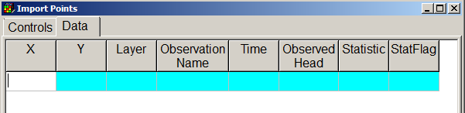
12. Now open the spreadsheet SS_WL_Obs.xlsx and copy and paste these values into Data Tab. Don’t foget to click on Apply. NOTE-We will not be using calibration, and the TIME is set to 0 the end of the steady-state stress period. The Statistic and StatFlag columns are for use with parameter estimation, which we are not going to do, but the numbers need to be set as in the spreadsheet.
13. Now we run the model again and look at the calculated fit between simulated and observed water levels. Go to Data Visualization window and click on the Head Observation Results and search for your “user_root_name”.hob_out file and select show residuals.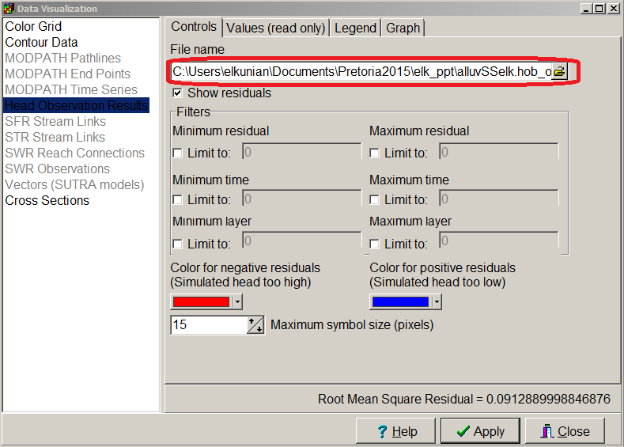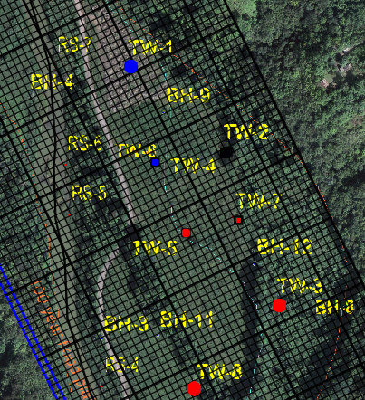
14. Experiment with the tabs as you can see graphs of residuals of simulated versus observed 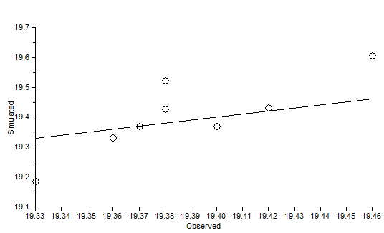 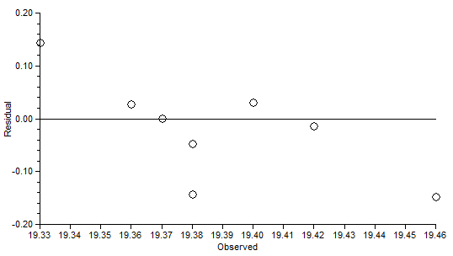

|  |  |  |  |
| --- | --- | --- | --- |
| Table 2.-Water levels in wells and river stage site (above local sea level datum). | | | |
| Identifier | Water level altitude meter |  |  |
| TW-1 | 19.33 |  |  |
| TW-2 | 19.37 |  |  |
| TW-3 | 19.38 |  |  |
| TW-4 | 19.40 |  |  |
| TW-5 | 19.38 |  |  |
| TW-6 | 19.36 |  |  |
| TW-7 | 19.42 |  |  |
| TW-8 | 19.46 |  |  |
| RS-2 | 20.12 |  |  |
| RS-3 | 19.81 |  |  |
| RS-4 | 19.46 |  |  |
| RS-5 | 19.45 |  |  |
| RS-6 | 19.16 |  |  |
| RS-7 | 19.16 |  |  |
| SG50036400 | 18.90 |  |  |
| SG50036200 | 20.51 |  |  |

## Setting up Transient Model to Simulate Initial Condition and Step Drawdown Test.

Water Levels were collected shortly before the step-drawdown test along with the river stage values during a period where there was not much rain and the river flow and stage was thought to be steady throughout the days before, during, and after the step-drawdown test. Transducers were installed in TW-6, TW-7, and TW-2 and pulled out at 5pm the next day. Set the initial SS period as the drawdown reference. Be certain head and drawdown are saved. Set Specific yield to 0.05 for this aquifer.

|  |  |  |
| --- | --- | --- |
| Table 3. Step Test Pumping Rates | | |
| Pumped well TW-4 | |  |
| start time | rate meter3/day |  |
| 8am | -1000 |  |
| 11am | -1500 |  |
| 2pm | -2000 |  |
| 5pm | 0 |  |

1. Before setting up transient stress periods with pumping Open AlluviumSS and save this as AlluviumTR. (Do not start with the one with head observations!)
2. Go to Model | MODFLOW Time menu, to add the required stress periods. Still include a steady-state initial period, then the transient period start with 3 more pumping periods and a period when the pump turns off for a day for a total of 5 stress periods. Calculate the elapsed time in days for the three pumping periods and the last stress period is 1 day. Hint- time zero is the start of the first pumping period. Three hours equals 0.125 days.
3. In Model|MODFLOW Options set starting head to the Steady State run head output file.
4. Remember to set the start and end time for the River feature, so it is active for the whole simulation time. Double click on that object to bring up the Object Properties window. And set start time for River to -1 and end time to the last total elapsed time (Hint 1.375).
5. Zoom into the area with wells TW-2 and TW-4, they may be in the same cell (depends on your grid) and add a point object and name it PumpingWell and Select that object and go to the MODFLOW feature , Select “WEL: Well package” and then put in your pumping rates for each stress period—see below.

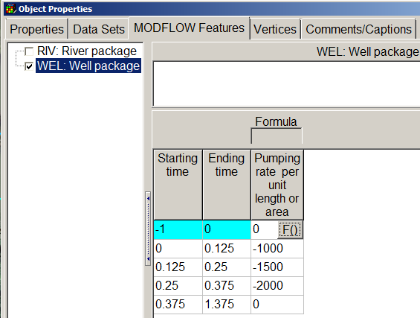

We are going to enter these head observations and see if our model is reasonable again before we try to move to the second part of this exercise and figure out where we can place a production well that can pump 1000 m3/day, in an area that does not get inundated, and will have a 60-day time of travel from the river to the well.

The spreadsheet TR_WL_Obs.xlsx has the transient water level altitudes provided by the drilling Company, but in the format required for reading into ModelMuse to create the HOB file.

1. Open Model MODFLOW Packages and Programs, expand Observations and check HOB: Head Observations to activate this package.
2. Go to File| Import points. Check Specify layer instead of elevation and Set values of intersected cells and under Features, select HOB: Head Observation package. Now select the Data tab and add the transient observations from the spreadsheet, just like for the steady-state observations. Don’t forget to click OK. Because there are multiple entries at the same point the objects menu has an entry for each well. 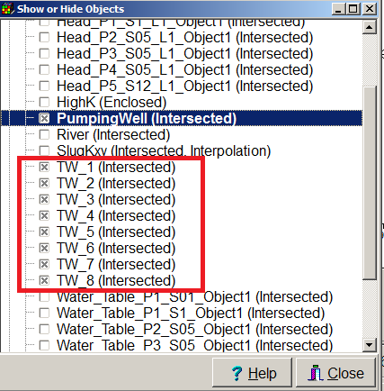
3. Now you need to fix one thing in each of the wells with multiple observations (TW-2, TW-6, and TW-7). So double click on one of these wells to bring up the Object Properties window and select the MODFLOW Features tab and set the “How will observations be analyzed? ITT to All heads with the button. It should look like this.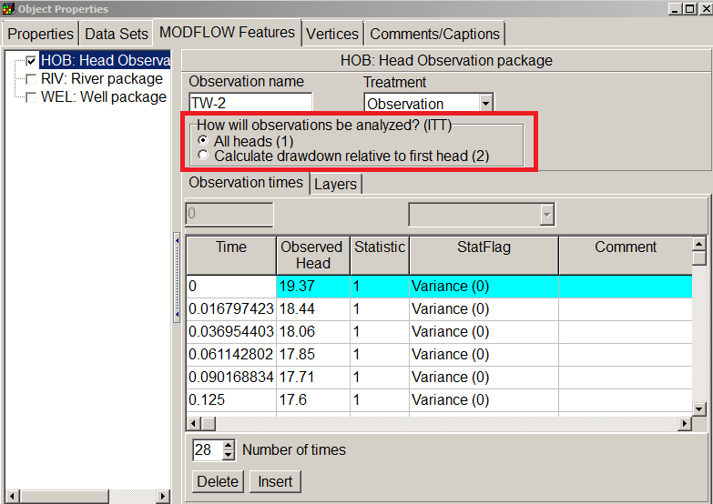
4. Do this for all three wells.
5. Run MODFLOW and import results, then in the Data Visualization window read in your hob_out file. In general with pump tests, the model cannot always duplicate things exactly.
6. Try to get you model a little more calibrated by adjusting K in the slug text file for the point at TW-4 and TW-2. Don’t spend too much time on this as you may run out of time to do phase 2 of problem 4. 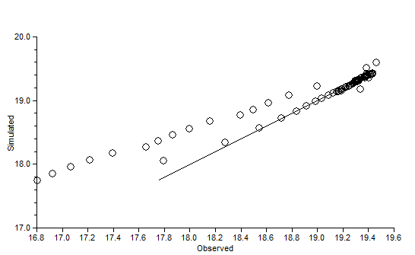

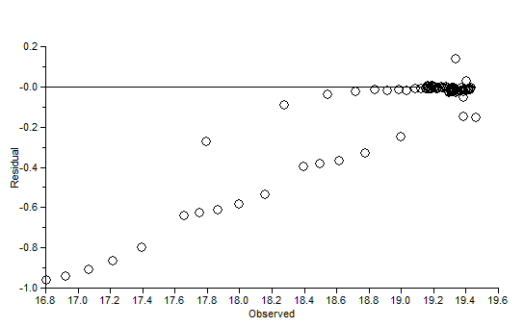

There is a little bias with the pump test in this examination of residuals, but the RMS is 0.27 so not that bad.

# Part 2 Where to Place a Production Well

## Set up MODPATH

1. Activate MODPATH and the Well package in the MODFLOW Packages and Programs dialog box.
2. For MODPATH, choose “Pathlines”,” Backwards” particle tracking and “Stop at termination points.”  
   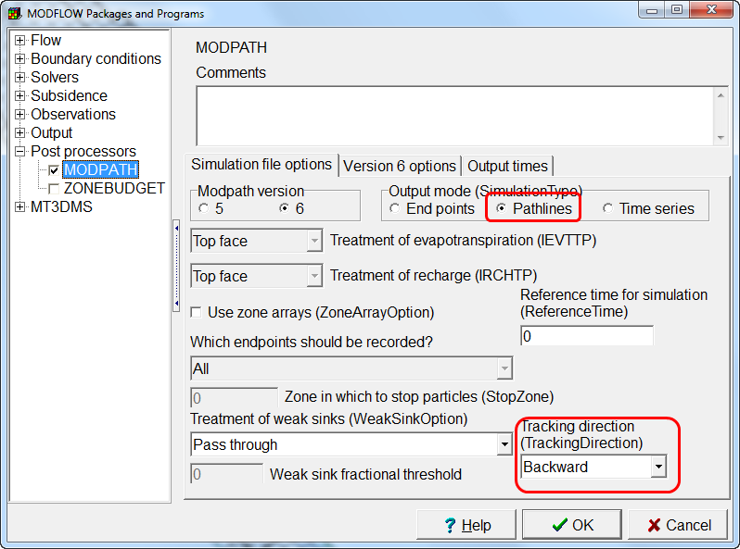 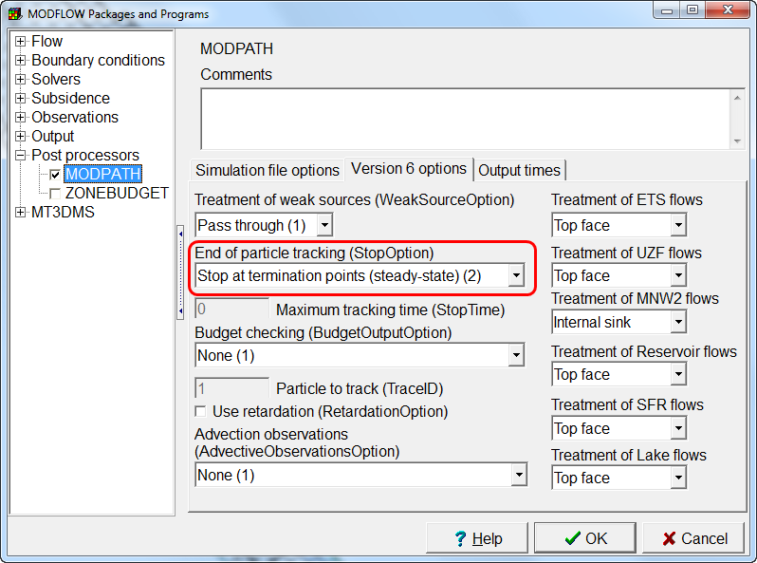
3. Create a point object and use it to define a well with a withdrawal rate of -1000. Also have it be the starting point for the MODPATH particles. You should have several particles on each lateral face of the cell. Probably start with putting particles around TW-4.
4. Remember to do steady-state simulation, but with the pumping well.
5. Decide if you want to add long-term recharge or not or see how the addition of recharge affects particles if you have time.
6. Select the Alluvium_area object and in Datasets select MODPATH porosity and you will see that the default porosity 0s 0.25, see how different porosity values affect travel time.

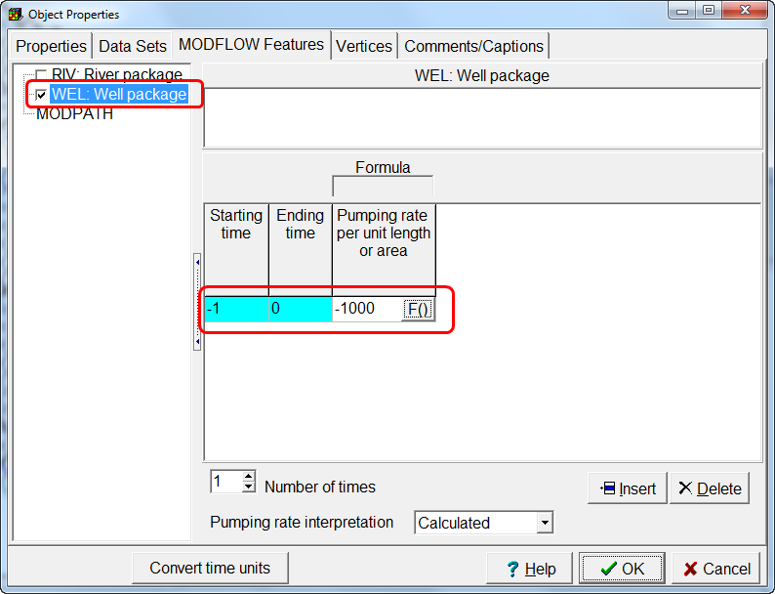 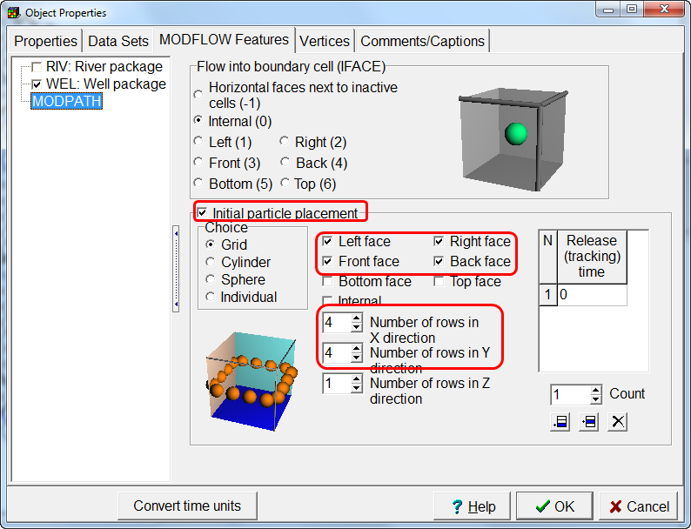

## Run the Model and Analyze results

Run the model Using the export MODFLOW files and check the listing file to make sure that the there is some flow to the well. If the cell containing the well went dry, the flow to the well will be zero. If that happens, try moving the well to a different location.  
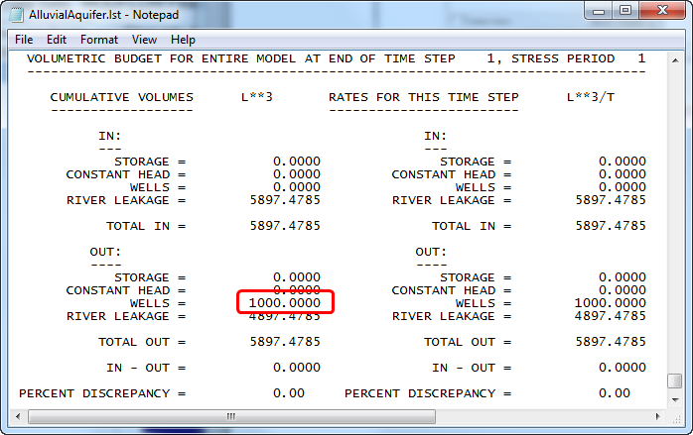

Import the MODPATH Pathlines in the Data Visualization Window. Then use the Grid or Mesh Values dialog box to check the travel time to the well from the river. If the travel time is too short, try moving the well to a different location.  
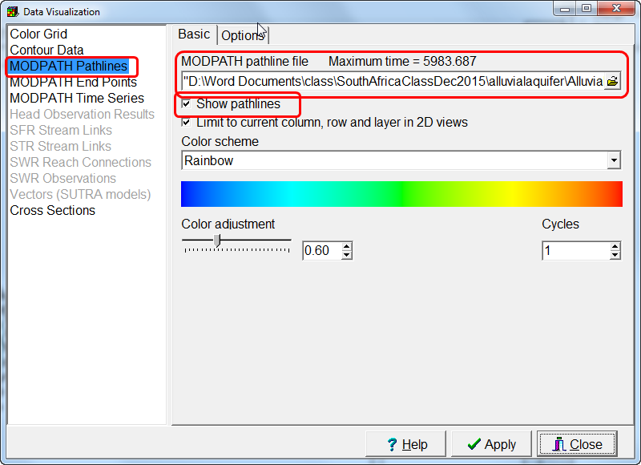 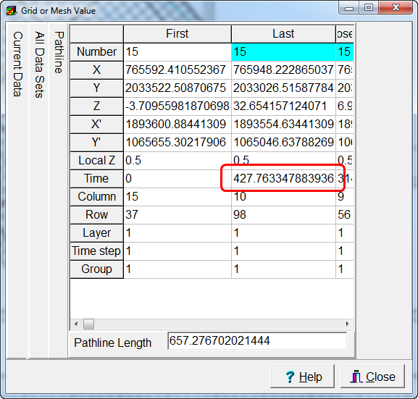

See what happens if you remove the particles from the well and put particles in the river cells and do forward tracking.

# Appendix 1 Site information

Geologic setting

This is a fairly small study area located on the north coast of Puerto Rico. Thick gravel floodplain alluvium is adjacent to the erosional channel cut by the Manati River (shown in yellow on figure 1). The area of alluvium, where the city has permission to install a well is proposed on the east side of the alluvium within the black rectangle (see figure 1 where cross-section A-A’ is drawn). Bedrock is tight (not very permeable) limestone and dolomite. The gravels are coarsest and have less fine material close to the current river channel. The porosity of the gravels ranges from 0.2 to 0.35. Hydraulic conductivity typically ranges from 1 to 40 m/day.

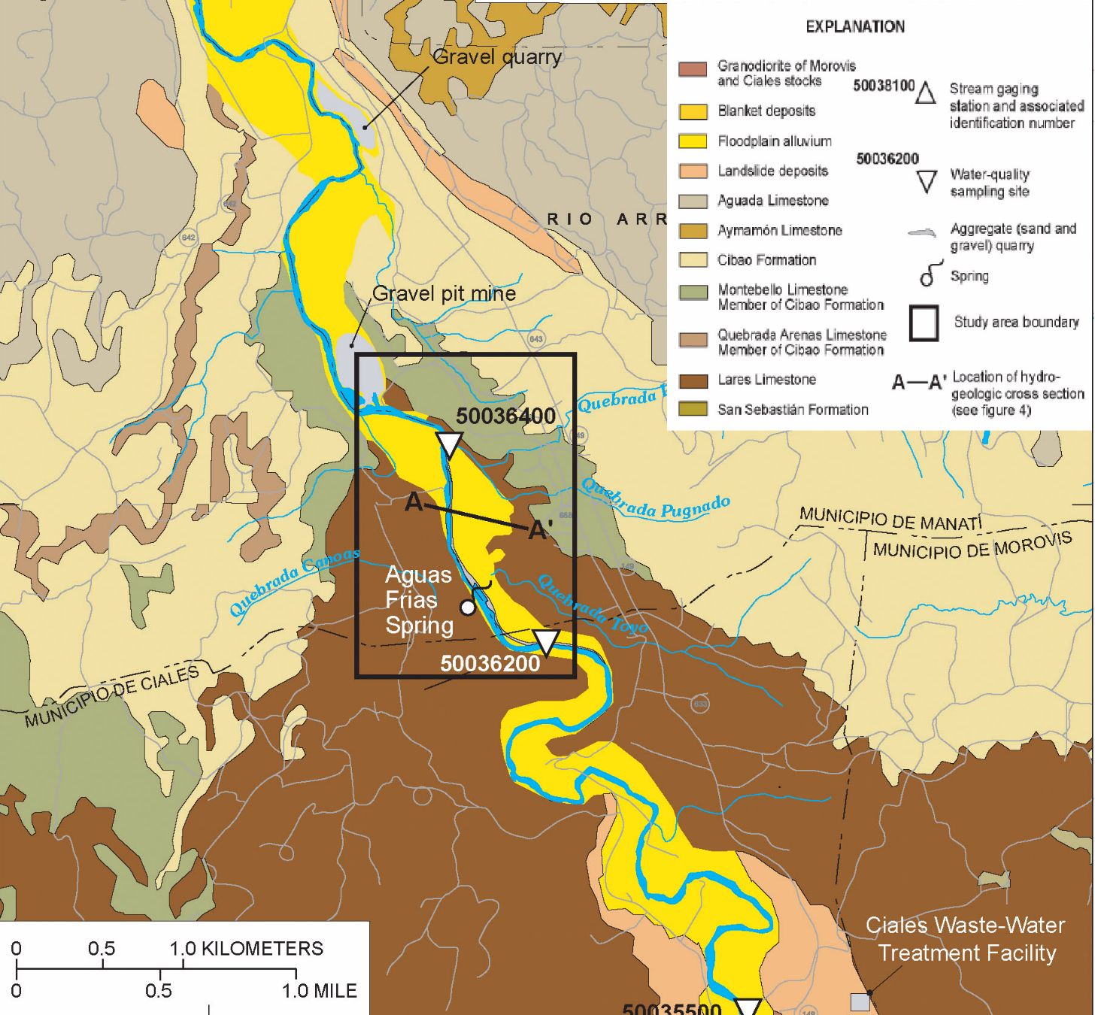

Figure 1-Surface geologic map showing quaternary alluvial deposit to be used to filter river water.

The average land surface in the study area is 28.00 m above sea level (local vertical datum) and on average the base of the alluvium is about 0 m local sea level datum based on cross section shown in figure 2.

Figure 2 Cross section A-A’ units of length and altitude are in meters, showing average stage of river.

Hydrology of Site

Puerto Rico has a very humid tropical climate and the study area is around 18 degrees north of the equator. Thus, rainfall and temperature both tend to not have seasonal signature, with the exception of large rain events of short duration from hurricanes and tropical storms. Annual rainfall is typically 1549 mm and the estimated average net recharge per year is 154.9 mm or 0.0004245 m/day.

The river tends to have fairly steady flow and stage except during these large storms (figure 3). The extent of a significant flood event is shown on figure 4 and indicates the areas near the river that do periodically become inundated during large storms.

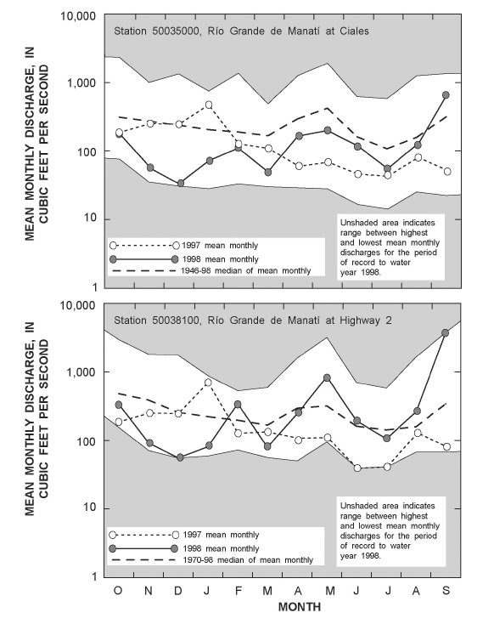

Figure 3- Mean monthly discharge at U.S. Geological Survey stream-gaging stations 50035000 and 50038100 for 1997 and 1998 water years. Also shown are the highest and lowest mean monthly discharge, as well as the long-term mean. The approximate locations of gaging stations 50035000 and 50038100 are shown in figure 1. Most of the 1997 and the first half of the 1998 water year were drier than normal.

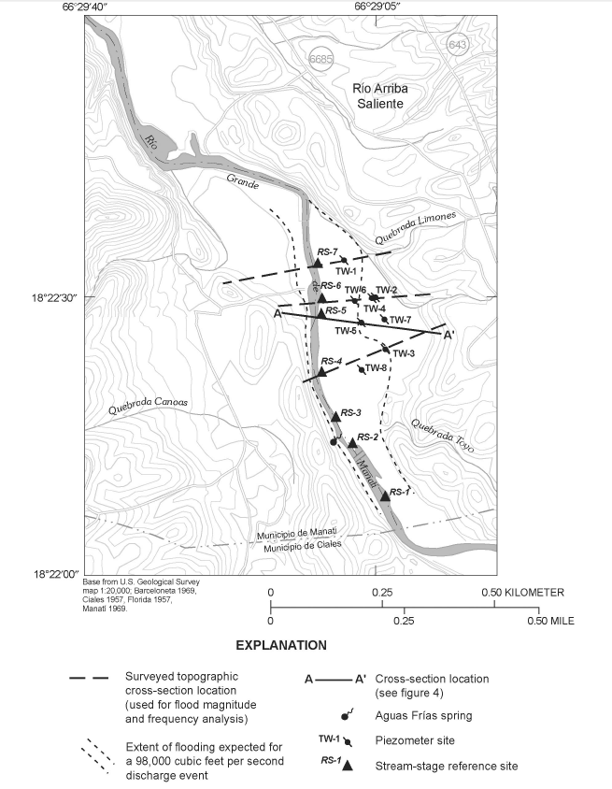

Figure 4. Extent of significant flooding event, location of piezometers, and location of selected sampling sites within the Río Grande de Manatí valley, Río Arriba Saliente area, Puerto Rico.

Data Collection

In April and May of 1998 exploratory data using a cone penetrometer to establish depth to bedrock were collected the refusal depth indicates the bottom of the alluvial gravel (BH-# for identifier), some of these points were completed with wells (TW-#, for wells). Figure 5 shows location of data collection sites and table 1 has geographic coordinate in WGS84 and other site information for wells and boreholes. Eight wells were completed and slug tests at the wells indicate a range of Kh from 14 to 32 m/day (table 1).

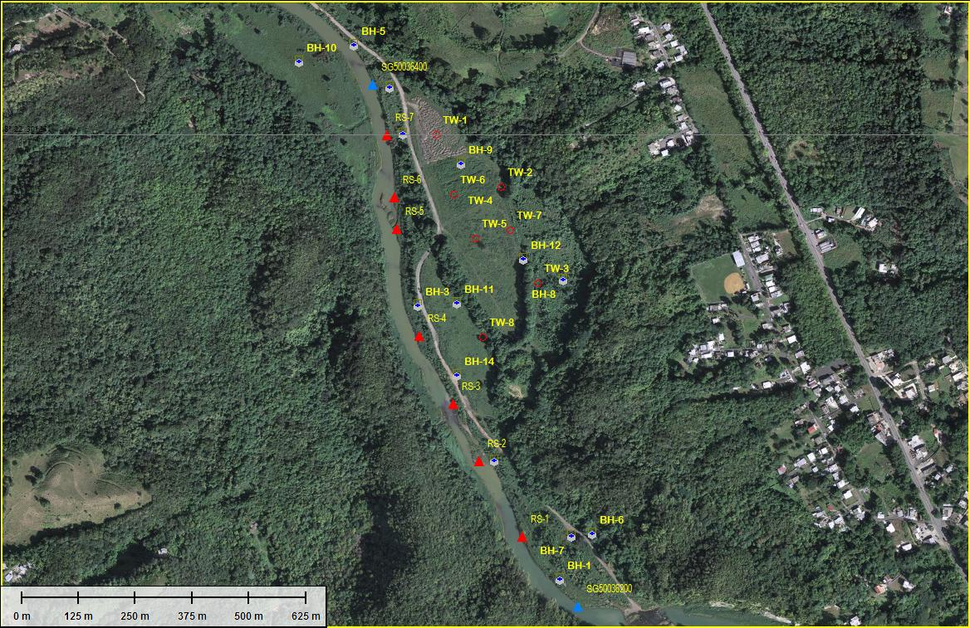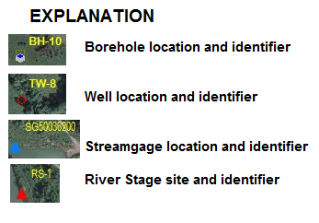

Figure 5. Location of data collection sites (image is on USB stick testsites.jpg).

|  |  |  |  |  |  |  |  |  |  |
| --- | --- | --- | --- | --- | --- | --- | --- | --- | --- |
| Table 1. Information on sites where data was collected and some results. | | | | | | | | | |
| LONGITUDE (WGS84) | LATITUDE (WGS84) | Identifier | SITE TYPE | CPT refusal meter | Well depth meter | Case dia cm | Screen below surface meter | Altitude Land surface meter | Kh in meter/day from slug tests |
| -66.4854884566 | 18.3750000000 | TW-1 | Well - Active | 20 | 13 | 10 | 10 to 13 | 28.54 | 16 |
| -66.4842018897 | 18.3739613432 | TW-2 | Well - Active | 19 | 16 | 10 | 13 to 16 | 29.11 | 20 |
| -66.4834834173 | 18.3720565558 | TW-3 | Well - Active | 22 | 13 | 10 | 10 to 13 | 29.61 | 14 |
| -66.4842318897 | 18.3739413432 | TW-4 | Well - Active | 34 | 19 | 10 | 7 to 19 | 29.28 | 20 |
| -66.4845695842 | 18.3709982667 | TW-8 | Well - Active | 25 | 12 | 5 | 9 to 12 | 28.40 | 35 |
| -66.4840348031 | 18.3731092015 | TW-7 | Well - Active | 28 | 12 | 5 | 9 to 12 | 29.06 | 25 |
| -66.4851375747 | 18.3738109652 | TW-6 | Well - Active | 26 | 12 | 5 | 9 to 12 | 28.64 | 34 |
| -66.4847223355 | 18.3729403907 | TW-5 | Well - Active | 28 | 12 | 10 | 9 to 12 | 29.28 | 32 |
| -66.4830210840 | 18.3661946514 | BH-1 | borehole | 28 |  |  |  |  |  |
| -66.4843206890 | 18.3685390368 | BH-2 | borehole | 29 |  |  |  |  |  |
| -66.4858241535 | 18.3715969308 | BH-3 | borehole | 27 |  |  |  |  |  |
| -66.4861299429 | 18.3750000000 | BH-4 | borehole | 30 |  |  |  |  |  |
| -66.4870982760 | 18.3767443856 | BH-5 | borehole | 27 |  |  |  |  |  |
| -66.4823840228 | 18.3670865371 | BH-6 | borehole | 22 |  |  |  |  |  |
| -66.4827917420 | 18.3670355722 | BH-7 | borehole | 26 |  |  |  |  |  |
| -66.4829701191 | 18.3721065798 | BH-8 | borehole | 23 |  |  |  |  |  |
| -66.4849832327 | 18.3744000003 | BH-9 | borehole | 30 |  |  |  |  |  |
| -66.4881685389 | 18.3764131138 | BH-10 | borehole | 28 |  |  |  |  |  |
| -66.4850596800 | 18.3716478957 | BH-11 | borehole | 27 |  |  |  |  |  |
| -66.4837507558 | 18.3725243983 | BH-12 | borehole | 28 |  |  |  |  |  |
| -66.4863847674 | 18.3759034648 | BH-13 | borehole | 30 |  |  |  |  |  |
| -66.4850596800 | 18.3702208785 | BH-14 | borehole | 31 |  |  |  |  |  |
| -66.4838053305 | 18.3670526354 | RS-1 | river stage site | |  |  |  |  |  |
| -66.4846450621 | 18.3685571544 | RS-2 | river stage site | |  |  |  |  |  |
| -66.4851523999 | 18.3696767965 | RS-3 | river stage site | |  |  |  |  |  |
| -66.4858346818 | 18.3710238658 | RS-4 | river stage site | |  |  |  |  |  |
| -66.4862720420 | 18.3731406891 | RS-5 | river stage site | |  |  |  |  |  |
| -66.4863245252 | 18.3737704878 | RS-6 | river stage site | |  |  |  |  |  |
| -66.4864644804 | 18.3750000000 | RS-7 | river stage site | |  |  |  |  |  |
| -66.4867443909 | 18.3759922775 | SG50036400 | Temporary Stream Gage | |  |  |  |  |  |
| -66.4826932648 | 18.3656913331 | SG50036200 | Temporary Stream Gage | |  |  |  |  |  |

On 28 May of 1998 water level and river stage data were collected at the site and then a step drawdown test conducted. A step drawdown test was conducted shortly after this water levels had not changed.

|  |  |  |  |
| --- | --- | --- | --- |
| Table 2.-Water levels in wells and river stage site (above local sea level datum). | | | |
| Identifier | Water level altitude meter | All collected right before step test. |  |
| TW-1 | 19.33 |  |  |
| TW-2 | 19.37 |  |  |
| TW-3 | 19.38 |  |  |
| TW-4 | 19.40 |  |  |
| TW-5 | 19.38 |  |  |
| TW-6 | 19.36 |  |  |
| TW-7 | 19.42 |  |  |
| TW-8 | 19.46 |  |  |
| RS-2 | 20.12 |  |  |
| RS-3 | 19.81 |  |  |
| RS-4 | 19.46 |  |  |
| RS-5 | 19.45 |  |  |
| RS-6 | 19.16 |  |  |
| RS-7 | 19.16 |  |  |
| SG50036400 | 18.90 |  |  |
| SG50036200 | 20.51 |  |  |

|  |  |  |
| --- | --- | --- |
| Table 3. Step Test Pumping Rates | | |
| Pumped well TW-4 | | |
| Did three pumping period steps | | |
| start time | rate meter3/day |  |
| 8am | -1000 |  |
| 11am | -1500 |  |
| 2pm | -2000 |  |

For the step drawdown test, there were only 3 transducers and data loggers. Wells TW-6, TW-7, and TW-2 were instrumented with transducers and data loggers. TW-4 is very close to TW-2 and is outside of the flood prone area. The step test was conducted to ensure that a 1,000 m3/day withdrawal rate is possible at the site. The drilling company provided drawdown and elapsed time from beginning of pumping for those 3 wells.

Figure 6. Drawdown data at observation wells.

Analysis of this test using an unconfined aquifer solution with partially penetrating wells is shown below.

The aquifer has a saturated thickness ranging from 10 to 32 m. 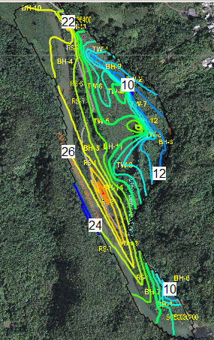

Figure shows saturated thickness before test (2 meter contour interval).

Unfortunately, the aquifer geometry and boundary conditions violate some of the assumptions of the analytical solutions (radial symmetry, constant thickness of infinite extent, and nearby no flow and recharge boundaries). Really none of these analytical solutions can be correctly applied. The Drilling company did fit the drawdown at TW-2 with Cooper-Jacob Straight line method and then plotted this in the Theis method to see if fit was reasonable. From this analysis, the transmissivity is about 210 m2/day and storage property about 0.03. It is hard to know the average thickness of the aquifer; however if we assume about 10 m at test area this is a K of 20 m/day, which matches the slug test at TW-4.

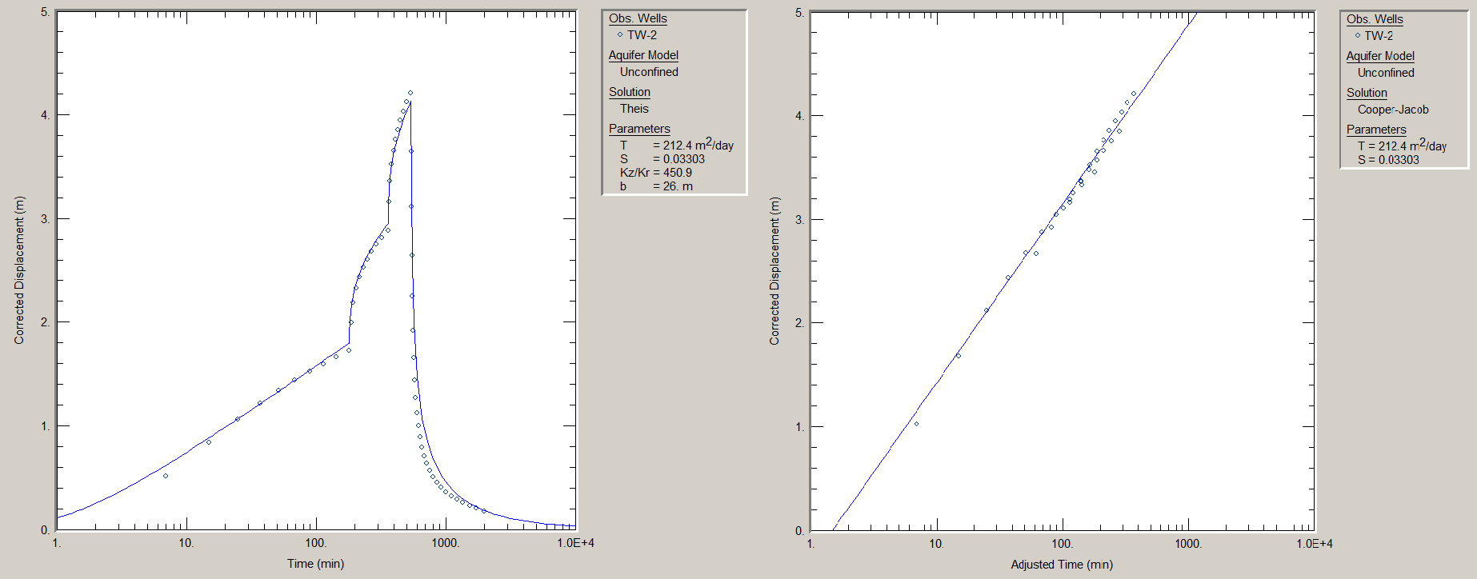

Data Confessions- The downloaded DEM dataset is in the WGS84 datum (horizontal and vertical), the Water Level altitudes collected are in the local Puerto Rico vertical datum and the lat lon in the table were eyeballed for WGS84 horizontal datum. So the DEM was over 5 meter off in vertical (lower), and the .xyz dataset from the ASTER GDEM v2 Worldwide Elevation Data was modified in the area of the alluvial aquifer to match the local Puerto Rico Datum. Additionally, the refusal depths were made up based on data collected to provide real world experience. The step test data was generated for this problem along with the slug test results.